**Erre asszem' 3ast vagy 4est kaptam, eléggé furán osztályoztak. Ez inkább az óra előtti felkészülésre jó, vannak benne hibák (1-2 félreszámolás) ezért érdemes utána számolgatni a dolgoknak.**

**Digitális technika II. laboratórium**

***2013/14***

**Mérést végezte:**

**Mérés vezető:** Vézner Imre

**Mérések időpontjai és felhasznált eszközök:**  
 EasyAbel - 2013. 09. 10.

számítógép

1. mérés - 2013. 09. 24.

univerzális mérőpanel, oszcilloszkóp, függvénygenerátor

2. mérés - 2013. 10. 8.

univerzális mérőpanel, oszcilloszkóp, függvénygenerátor

3. mérés - 2013. 10. 22.

univerzális mérőpanel, oszcilloszkóp, függvénygenerátor

4. mérés - 2013. 11. 5.

univerzális mérőpanel, ACM kártya

5. mérés - 2013. 12. 3.

**1. mérés Kombinációs áramkörök vizsgálata**

F=∑(1,3,9,11,12,13,14,15)

A0, B0, C0, D0

|  |  |  |  |  |  |  |
| --- | --- | --- | --- | --- | --- | --- |
|  |  |  | A | |  |  |
| DC\BA | *00* | *01* | *11* | *10* |  |
|  | *00* |  | 1 | 1 |  |  |
|  | *01* |  |  |  |  | C |
| D | *11* | 1 | 1 | 1 | 1 |
| *10* |  | 1 | 1 |  |  |
|  |  |  |  | B | |  |
|  |  |  |  |  |  |  |

De Morgan azonosságok:

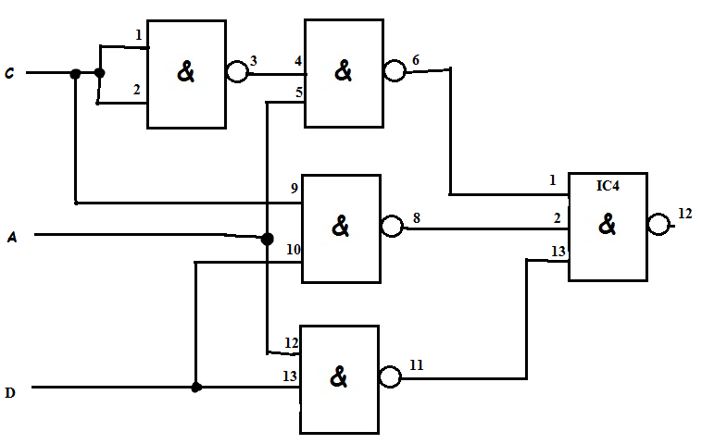 $\overline{AB}=\overline{A}+\overline{B}$ $$\overline{A+B}=\overline{A}\overline{B}$$

Hazárdos

$$F=CD+A\overline{C} \\ \overset{̿}{F=CD+A\overline{C}}=\overline{\overline{CD}\overline{A\overline{C}}}$$

Hazárd mentesen:

$$F=CD+A\overline{C}+DA \\ F=\overset{̿}{CD+A\overline{C}+DA}=\overline{\overline{CD} \overline{A\overline{C}} \overline{DA}}$$

|  |  |  |  |
| --- | --- | --- | --- |
| DCBA | Fsz | Fm |  |
| 0000 | 0 | 0 | 0 |
| 0001 | 1 | 1 | IMP |
| 0010 | 0 | 0 | 0 |
| 0011 | 1 | 1 | IMP |
| 0100 | 0 | 0 | 0 |
| 0101 | 0 | 0 | IMP |
| 0110 | 0 | 0 | 0 |
| 0111 | 0 | 0 | IMP |
| 1000 | 0 | 0 | IMP |
| 1001 | 1 | 1 | 1 |
| 1010 | 0 | 0 | IMP |
| 1011 | 1 | 1 | 1 |
| 1100 | 1 | 1 | IMP |
| 1101 | 1 | 1 | 1 |
| 1110 | 1 | 1 | IMP |
| 1111 | 1 | 1 | 1 |

**2. mérés Elemi tárolók vizsgálata**

2.1.

|  |  |  |  |
| --- | --- | --- | --- |
| SR | CP | Q | !Q |
| 00 | 0 | 0 | 1 |
| 00 | 1 | 0 | 1 |
| 01 | 0 | 0 | 1 |
| 01 | 1 | 1 | 1 |
| 10 | 0 | 1 | 0 |
| 10 | 1 | 1 | 1 |
| 11 | 0 | 1 | 0 |
| 11 | 1 | 1 | 1 |

2.2

|  |  |  |  |
| --- | --- | --- | --- |
| PR | C | Q | !Q |
| 0 | 1 | 1 | 0 |
| 1 | 0 | 0 | 1 |
|  |  |  |  |
| PR | C |  |  |
| S | R | Q | !Q |
| 0 | 1 | 0 | 1 |
| 1 | 0 | 1 | 0 |

2.3

JK vezérlési tábla:

|  |  |  |  |
| --- | --- | --- | --- |
| J | K | Q | Q! |
| 0 | 0 | 1 | 0 |
| 0 | 1 | 0 | 1 |
| 1 | 0 | 1 | 0 |
| 1 | 1 | x | x |

2.5.

|  |  |  |  |  |
| --- | --- | --- | --- | --- |
| Imp | Q1 | Q2 | Q3 | Q4 |
| 0 | 1 | 1 | 1 | 1 |
| 1 | 0 | 1 | 1 | 1 |
| 2 | 1 | 0 | 1 | 1 |
| 3 | 0 | 1 | 0 | 1 |
| 4 | 1 | 0 | 1 | 0 |
| 5 | 0 | 1 | 0 | 1 |

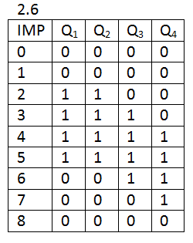

**3. mérés Sorrendi áramkörök tervezése és mérése**

|  |  |  |  |  |  |  |
| --- | --- | --- | --- | --- | --- | --- |
| **D3** |  |  | X3 | |  |  |
| DC\BA | *00* | *01* | *11* | *10* |  |
|  | *00* | 1 | 1 | 1 | X |  |
|  | *01* | X | X | 1 | X | X1 |
| X0 | *11* |  | X |  |  |
| *10* | 1 | X | X | X |  |
|  |  |  |  | X2 | |  |
| **D2** |  |  | X3 | |  |  |
| DC\BA | *00* | *01* | *11* | *10* |  |
|  | *00* |  | 1 | 1 | X |  |
|  | *01* | X | X | 1 | X | X1 |
| X0 | *11* |  | X | 1 |  |
| *10* |  | X | X | X |  |
|  |  |  |  | X2 | |  |
| **D1** |  |  | X3 | |  |  |
| DC\BA | *00* | *01* | *11* | *10* |  |
|  | *00* |  |  | 1 | X |  |
|  | *01* | X | X | 1 | X | X1 |
| X0 | *11* |  | X | 1 | 1 |
| *10* |  | X | X | X |  |
|  |  |  |  | X2 | |  |
| **D0** |  |  | X3 | |  |  |
| DC\BA | *00* | *01* | *11* | *10* |  |
|  | *00* |  |  |  | X |  |
|  | *01* | X | X | 1 | X | X1 |
| X0 | *11* | 1 | X | 1 | 1 |
| *10* |  | X | X | X |  |
|  |  |  |  | X2 | |  |

3.4

|  |  |  |  |  |  |  |  |  |
| --- | --- | --- | --- | --- | --- | --- | --- | --- |
| I | X3 | X2 | X1 | X0 | D3 | D2 | D1 | D0 |
| 0 | 0 | 0 | 0 | 0 | 1 | 0 | 0 | 0 |
| 1 | 1 | 0 | 0 | 0 | 1 | 1 | 0 | 0 |
| 2 | 1 | 1 | 0 | 0 | 1 | 1 | 1 | 0 |
| 3 | 1 | 1 | 1 | 0 | 1 | 1 | 1 | 1 |
| 4 | 1 | 1 | 1 | 1 | 0 | 1 | 1 | 1 |
| 5 | 0 | 1 | 1 | 1 | 0 | 0 | 1 | 1 |
| 6 | 0 | 0 | 1 | 1 | 0 | 0 | 0 | 1 |
| 7 | 0 | 0 | 0 | 1 | 1 | 0 | 0 | 0 |
| 8 | 1 | 0 | 0 | 0 |  |  |  |  |

D3=!X0+!X1=!(X0X1)

D2=X3

D1=X2

D0=X1

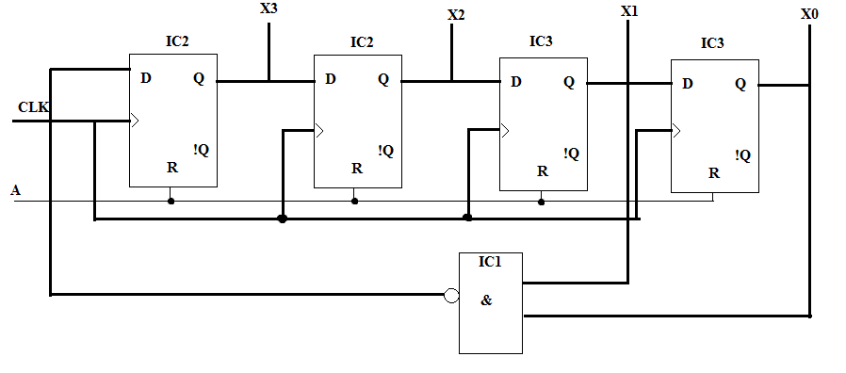

3.5

|  |  |  |  |  |  |  |  |  |  |
| --- | --- | --- | --- | --- | --- | --- | --- | --- | --- |
|  | | | | A | | B | | C | |
| i | A | B | C | J | K | J | K | J | K |
| 0 | 0 | 0 | 0 | 1 | X | 0 | X | 0 | X |
| 1 | 1 | 0 | 0 | X | 0 | 1 | X | 0 | X |
| 2 | 1 | 1 | 0 | X | 0 | X | 0 | 1 | X |
| 3 | 1 | 1 | 1 | X | 1 | X | 0 | X | 0 |
| 4 | 0 | 1 | 1 | 0 | X | X | 1 | X | 1 |
| 5 | 0 | 0 | 0 | 1 | X | 0 | X | 0 | X |

|  |  |  |  |  |
| --- | --- | --- | --- | --- |
| KA |  | C | |  |
|  | X | X | X | X |
| A | 0 | 1 | 1 | 0 |
|  |  |  | B | |

|  |  |  |  |  |
| --- | --- | --- | --- | --- |
| JA |  | C | |  |
|  | 1 | 1 | 0 | X |
| A | X | X | X | X |
|  |  |  | B | |

|  |  |  |  |  |
| --- | --- | --- | --- | --- |
| JB |  | C | |  |
|  | 0 | X | X | X |
| A | 1 | X | X | X |
|  |  |  | B | |

|  |  |  |  |  |
| --- | --- | --- | --- | --- |
| KB |  | C | |  |
|  | X | X | 1 | X |
| A | 0 | X | 1 | 0 |
|  |  |  | B | |

|  |  |  |  |  |
| --- | --- | --- | --- | --- |
| JC |  | C | |  |
|  | 0 | X | X | X |
| A | 0 | X | X | 1 |
|  |  |  | B | |

|  |  |  |  |  |
| --- | --- | --- | --- | --- |
| KC |  | C | |  |
|  | X | X | 1 | X |
| A | X | X | 0 | X |
|  |  |  | B | |

JA=!B JB=A JC=B

KA=C KB=!A KC=!A

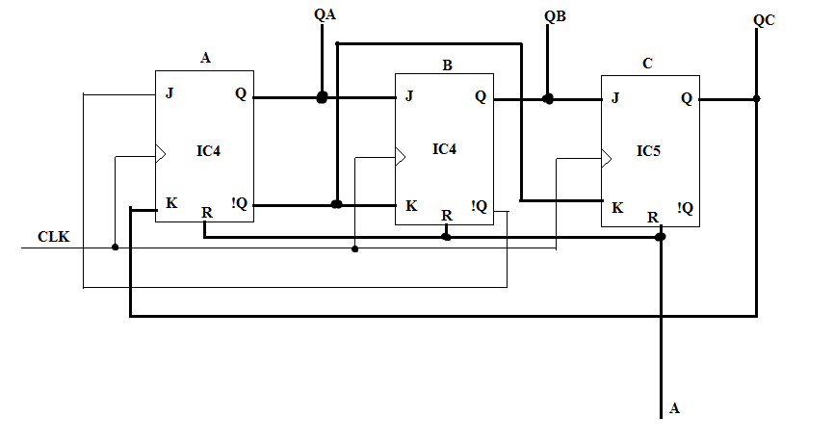

3.6

|  |  |  |  |  |  |  |
| --- | --- | --- | --- | --- | --- | --- |
| imp | A | B | C | DA | DB | DC |
| 0 | 0 | 0 | 0 | 1 | 0 | 0 |
| 1 | 1 | 0 | 0 | 1 | 1 | 0 |
| 2 | 1 | 1 | 0 | 1 | 1 | 1 |
| 3 | 1 | 1 | 1 | 0 | 1 | 1 |
| 4 | 0 | 1 | 1 | 0 | 0 | 1 |
| 5 | 0 | 0 | 1 | 1 | 0 | 0 |
| 6 | 1 | 0 | 0 | 0 | 0 | 0 |

|  |  |  |  |  |
| --- | --- | --- | --- | --- |
| DA |  | C | |  |
|  | 1 | 1 | 0 | X |
| A | 1 | X | 0 | 1 |
|  |  |  | B | |

|  |  |  |  |  |
| --- | --- | --- | --- | --- |
| DB |  | C | |  |
|  | 0 | 0 | 0 |  |
| A | 1 | X | 1 | 1 |
|  |  |  | B | |

|  |  |  |  |  |
| --- | --- | --- | --- | --- |
| DC |  | C | |  |
|  | 0 | 0 | 1 | X |
| A | 0 |  | 1 | 1 |
|  |  |  | B | |

DA=!C+!B=!(CB)

DB=A

DC=B

**4. mérés Aritmetikai elemek vizsgálata**

1. feladat

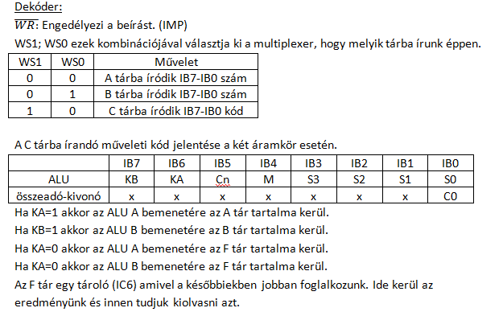

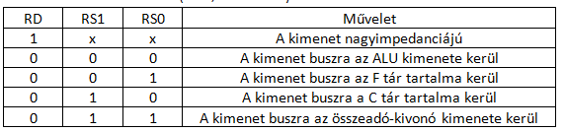

Általunk választott két szám: A=00110011 és B=11001100.

A tárba beírunk A-t: WS1=0; WS0=0 bemeneteken beállítjuk A számot(IB7-IB0). WR impulzus hatására beíródik a szám. WS1=0; WS0=1 bemeneteken beállítjuk B számot(IB7-IB0). WR impulzus hatására beíródik a szám.

C-be írás: WS1=1; WS0=0 az utasításkódot a bemeneten állítjuk be(IB7-IB0)

IB7=IB6=1, IB5=X, IB4=1 és az ALU S3, S2, S1, S0 kiválasztó bemenetei az (IB3-IB0)

Esetünkben ezek a következők voltak:

F=A 11X1_0000

F=A+B 11X1_0001

F=A+B 11X1_1110

F=AB 11X1_1011

Az eredmény az ALU kimenetén olvasható vissza mivel logikai műveletet hajtottunk végre.

Kiolvasás; RS1=RS0=0, RD=0

F1=11001100

F2=00000000

F3=11111111

F4=00000000

2. feladat

Két számmal logikai és aritmetikai műveletek

